**LETSUPGRADE LINUX ADMINSTRATION**

**DAY 3 ASSIGNMENT**

Question 1

1. Create a blank file named “myfile”
2. Open “myfile” in vi editor
3. Write your name, address, email id, phone number and blood group in 5 different lines
4. Build one single expression to see the line with your name and blood group in myfile

**ANS 1 .**

**Creating And Verifying** myfile **By Using touch command**

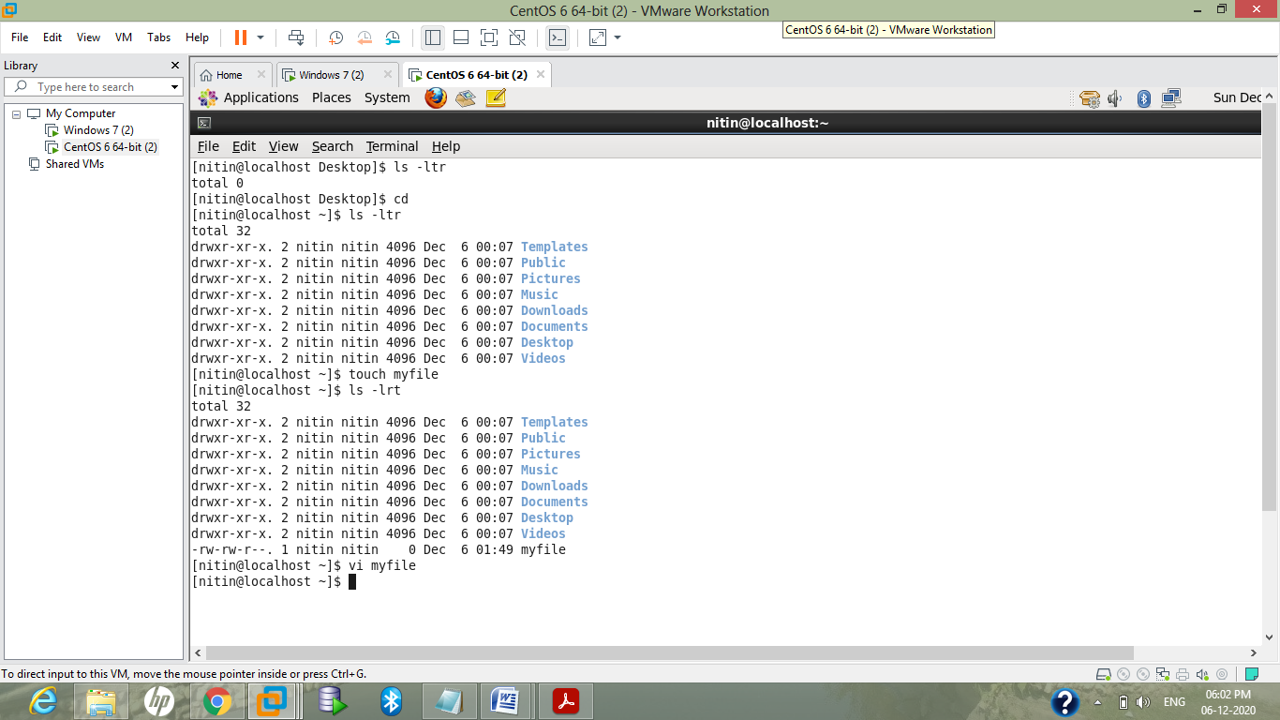

**ANS 2.**

**Opening The File Using Vi Editor:**

**vi myfile**

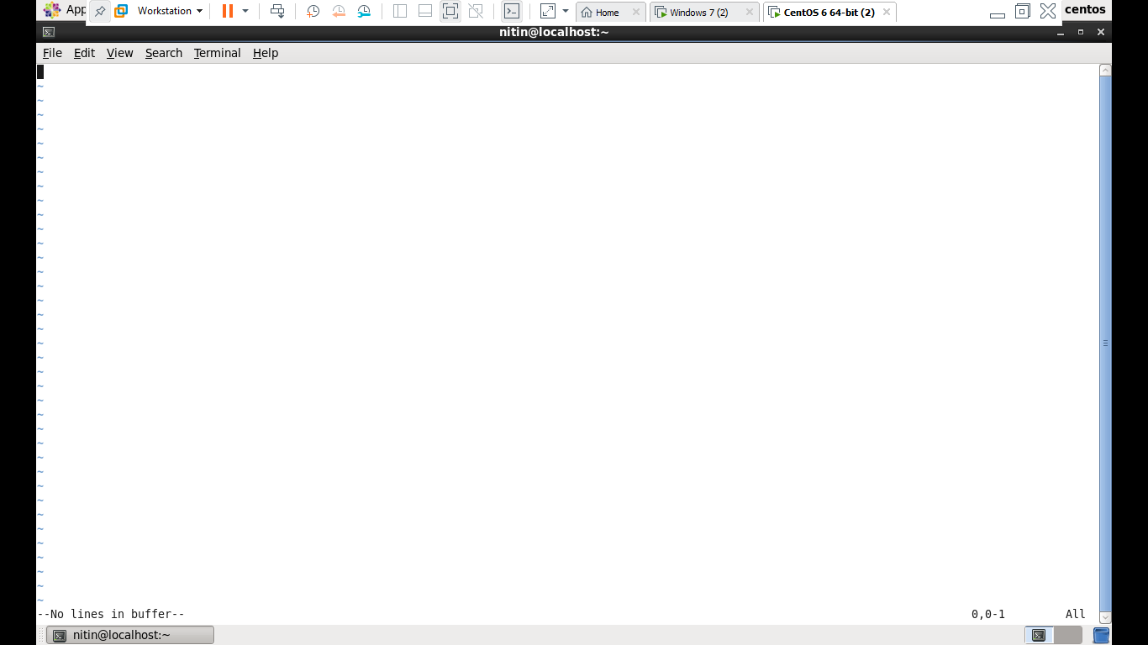

**ANS 3 .**

**Pressing i for insert mode :**

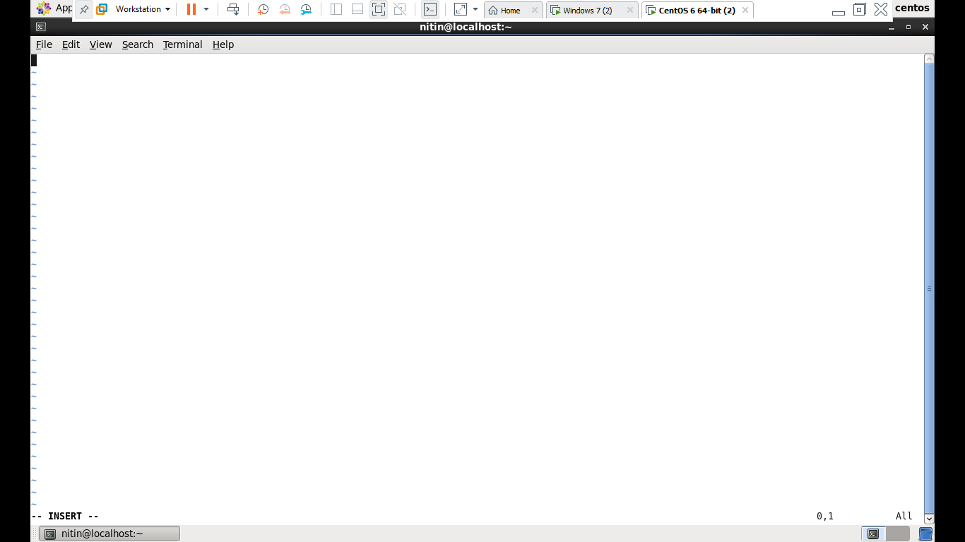

**Writing The Details And Saving It By Using :wq! Then Opening It By Using cat command**

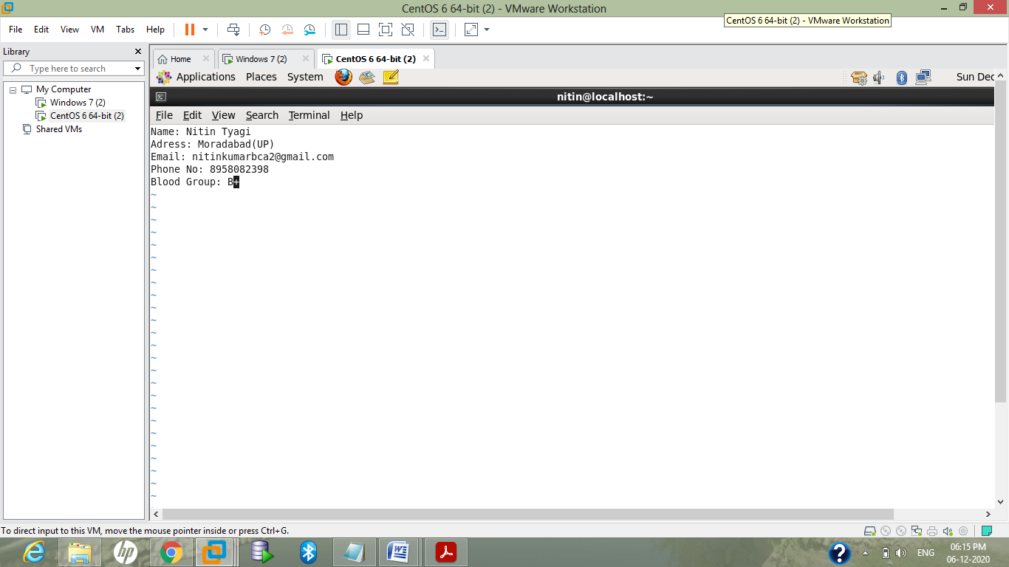

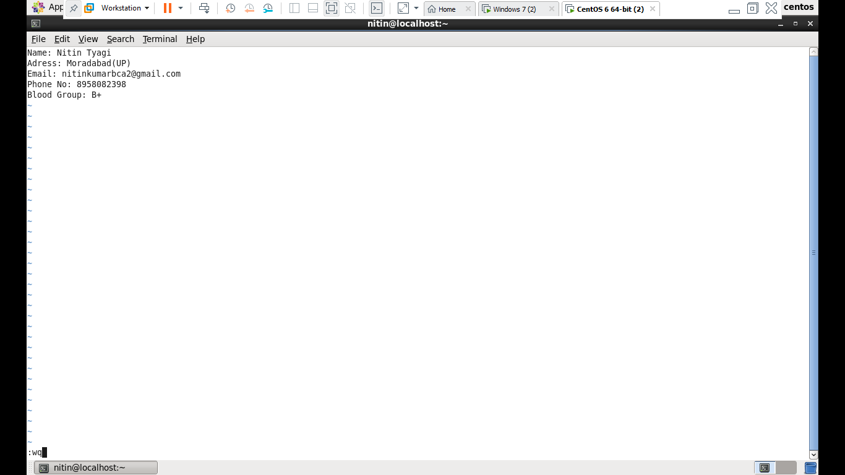

**verfiying contents after writing and saving:**

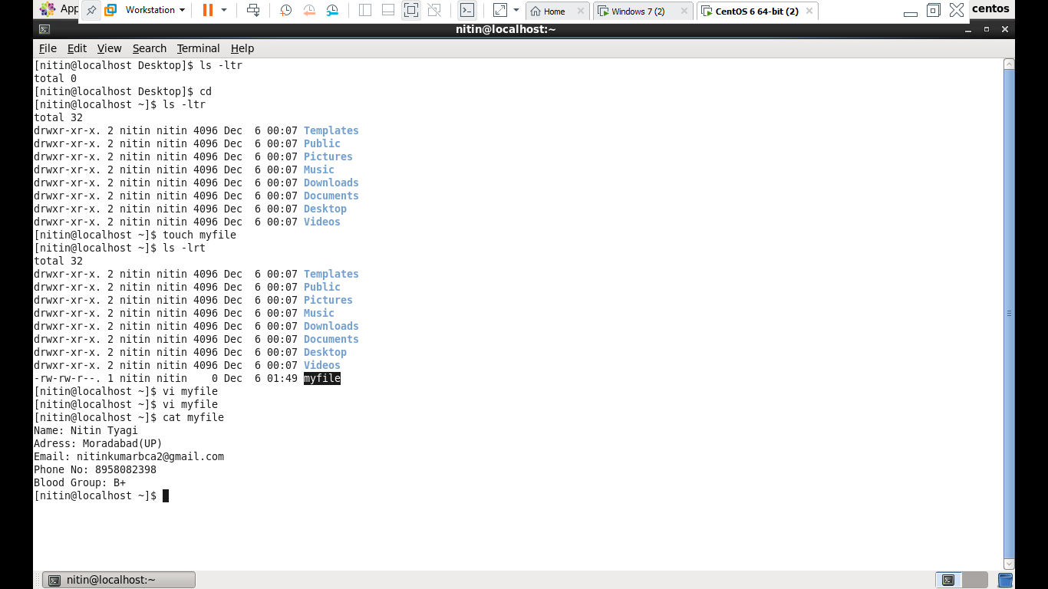

**ANS 4.**

**Creating one single expression to find the name and blood group line**

**using grep command**

